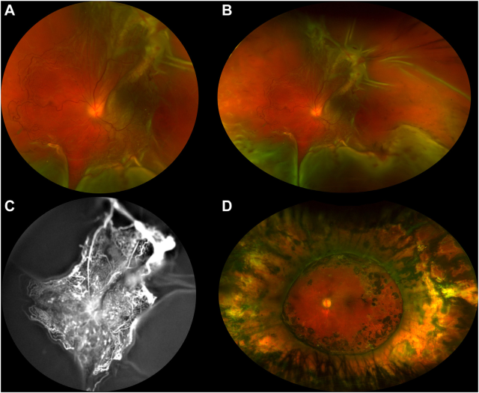

A 6-year-old boy presented with a total retinal detachment (RD) in the left eye (A, B). The midperipheral and peripheral retina were mostly avascular. Immature vessels were confined to the posterior retina and preretinal new vesselsinduced a posterior retinal tear (C). He underwent pars plana vitrectomy with scleral buckling and silicone oil tamponade resulting insuccessful reattachment of the retina. After silicone oil removal (D), visual acuity was 1/10. Based on the provided images and clinical description please make an ophthalmic diagnosis for this patient. And output the diagnostic conclusions only.

**Familial Exudative Vitreoretinopathy (FEVR)**